**100 Books To Read In Key Stage 1**

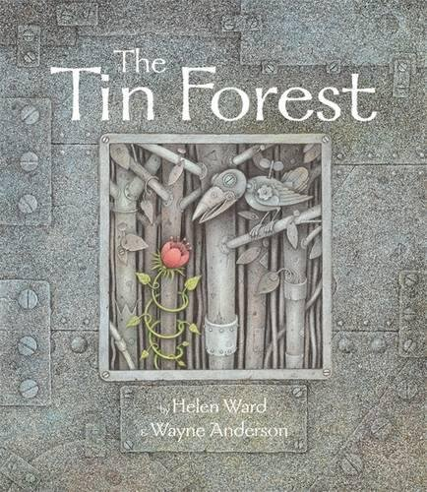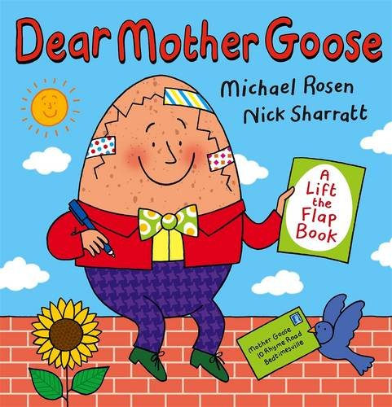

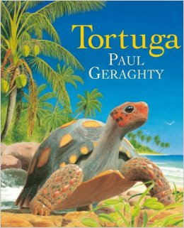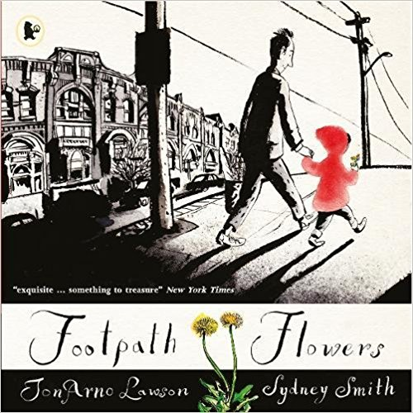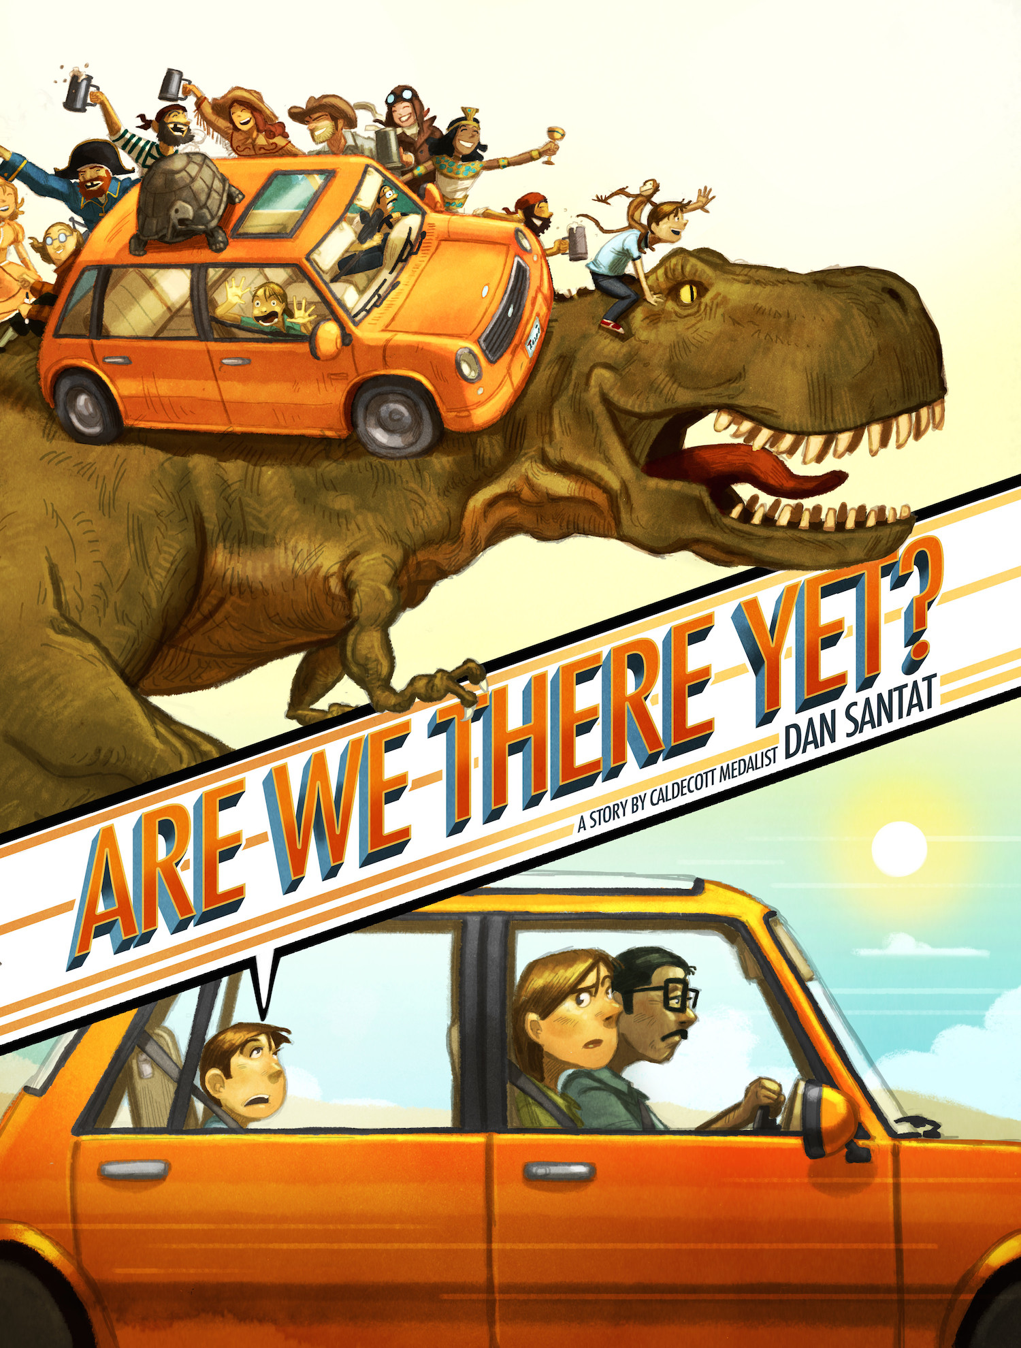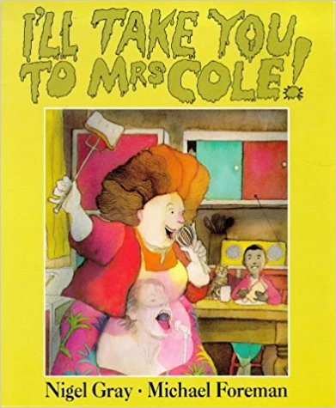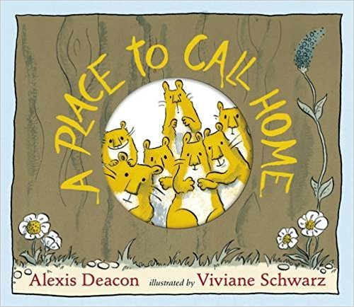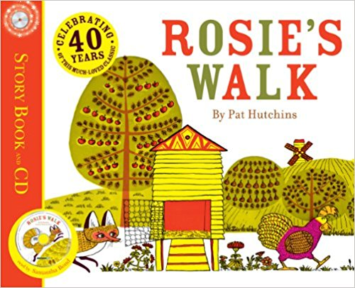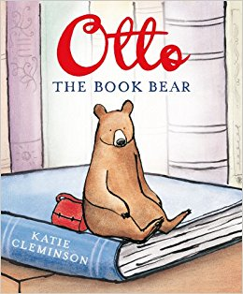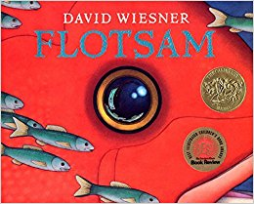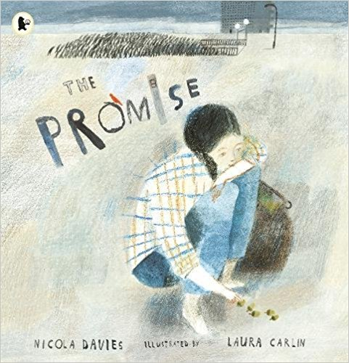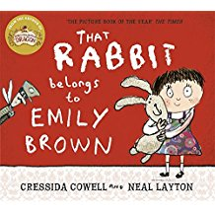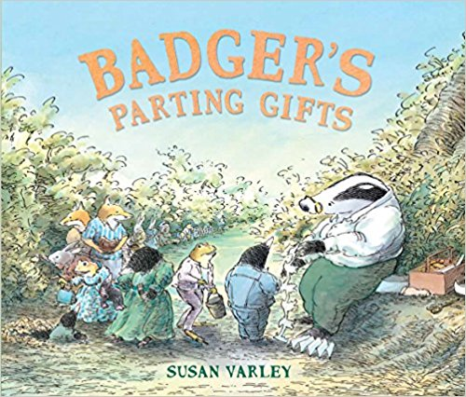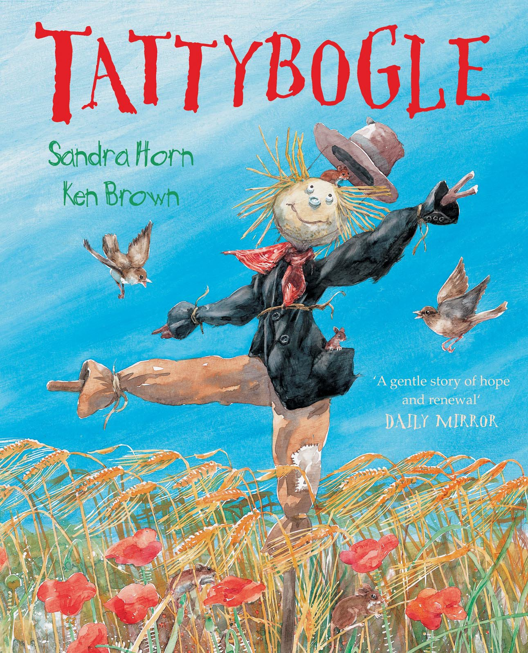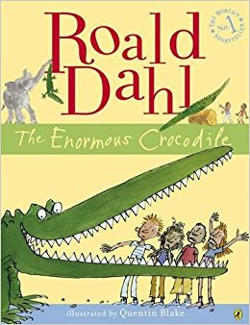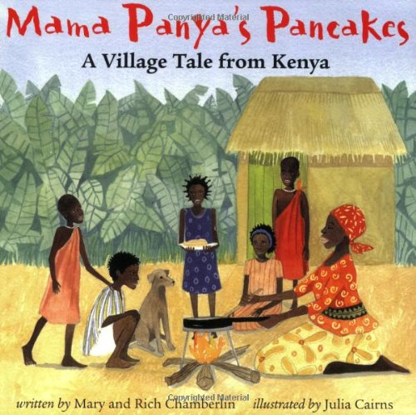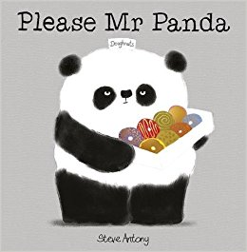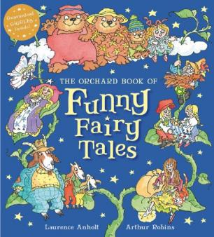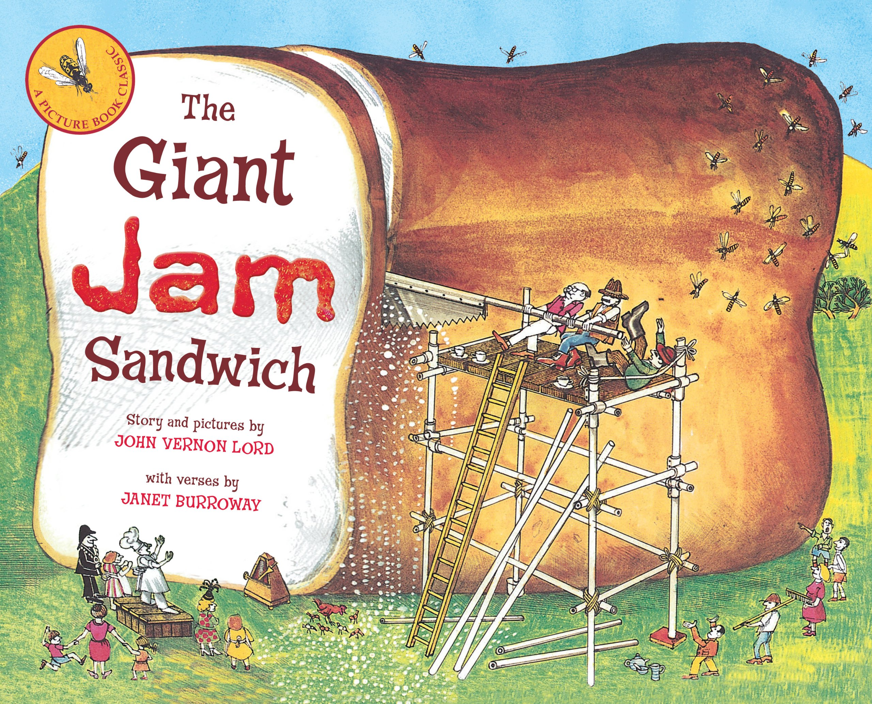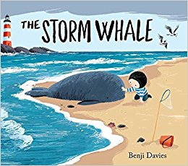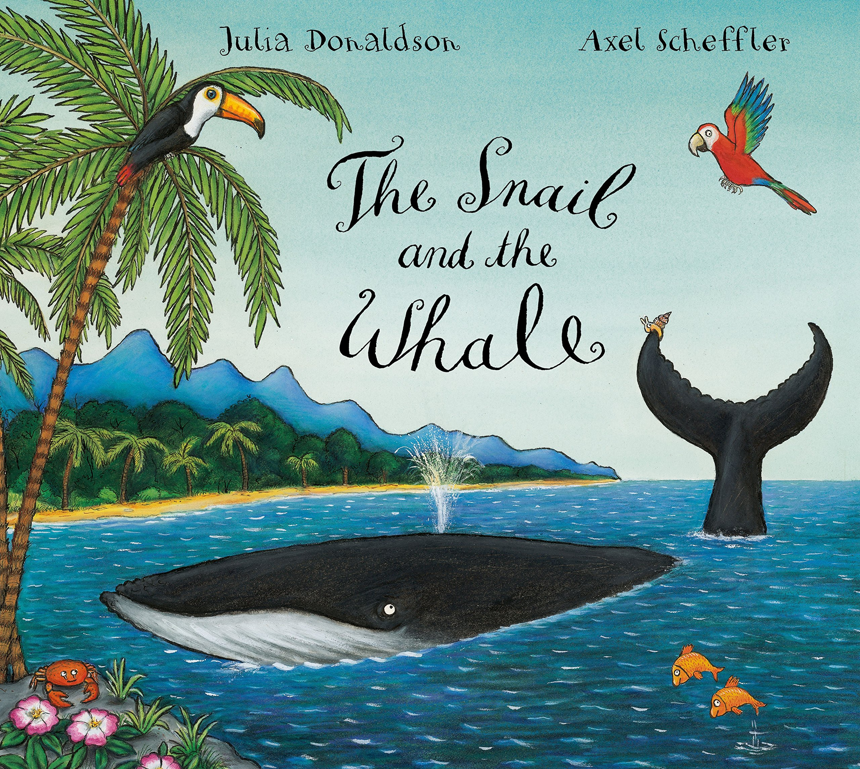 v v

The Storm Whale

Benji Davies

The Enormous Crocodile

Roald Dahl

Dear Mother Goose

Michael Rosen and Nick Sharratt

That Rabbit Belongs To Emily Bown

Cressida Coweel and Neal Layton

Mama Panya’s Pancakes

Mary and Rich Chamberlain

Please Mr Panda

Steve Antony

Tortuga

Paul Geraghty

Footpath Flowers

Jon Arno Lawson

Are We There Yet?

Dan Santat

I’ll Take You To Mrs Cole

Nigel Gray

A Place To Call Home

Alexis Deacon

Rosie’s Walk

Pat Hutchinson

Otto The Book Bear

Katie Cleminson

Flotsam

David Wiesner

The Promise

Nicola Davies

Badger’s Parting Gifts

Susan Varley

Tattybogle

Sandra Horn and Ken Brown

Funny Fairy Tales

Laurence Anholt and Arthut Robins

The Giant Jam Sandwich

John Vernon Lord and Janet Burroway

The Tin Forest

Helen Ward and Wayne Anderson

The Snail and the Whale

Julia Donaldson