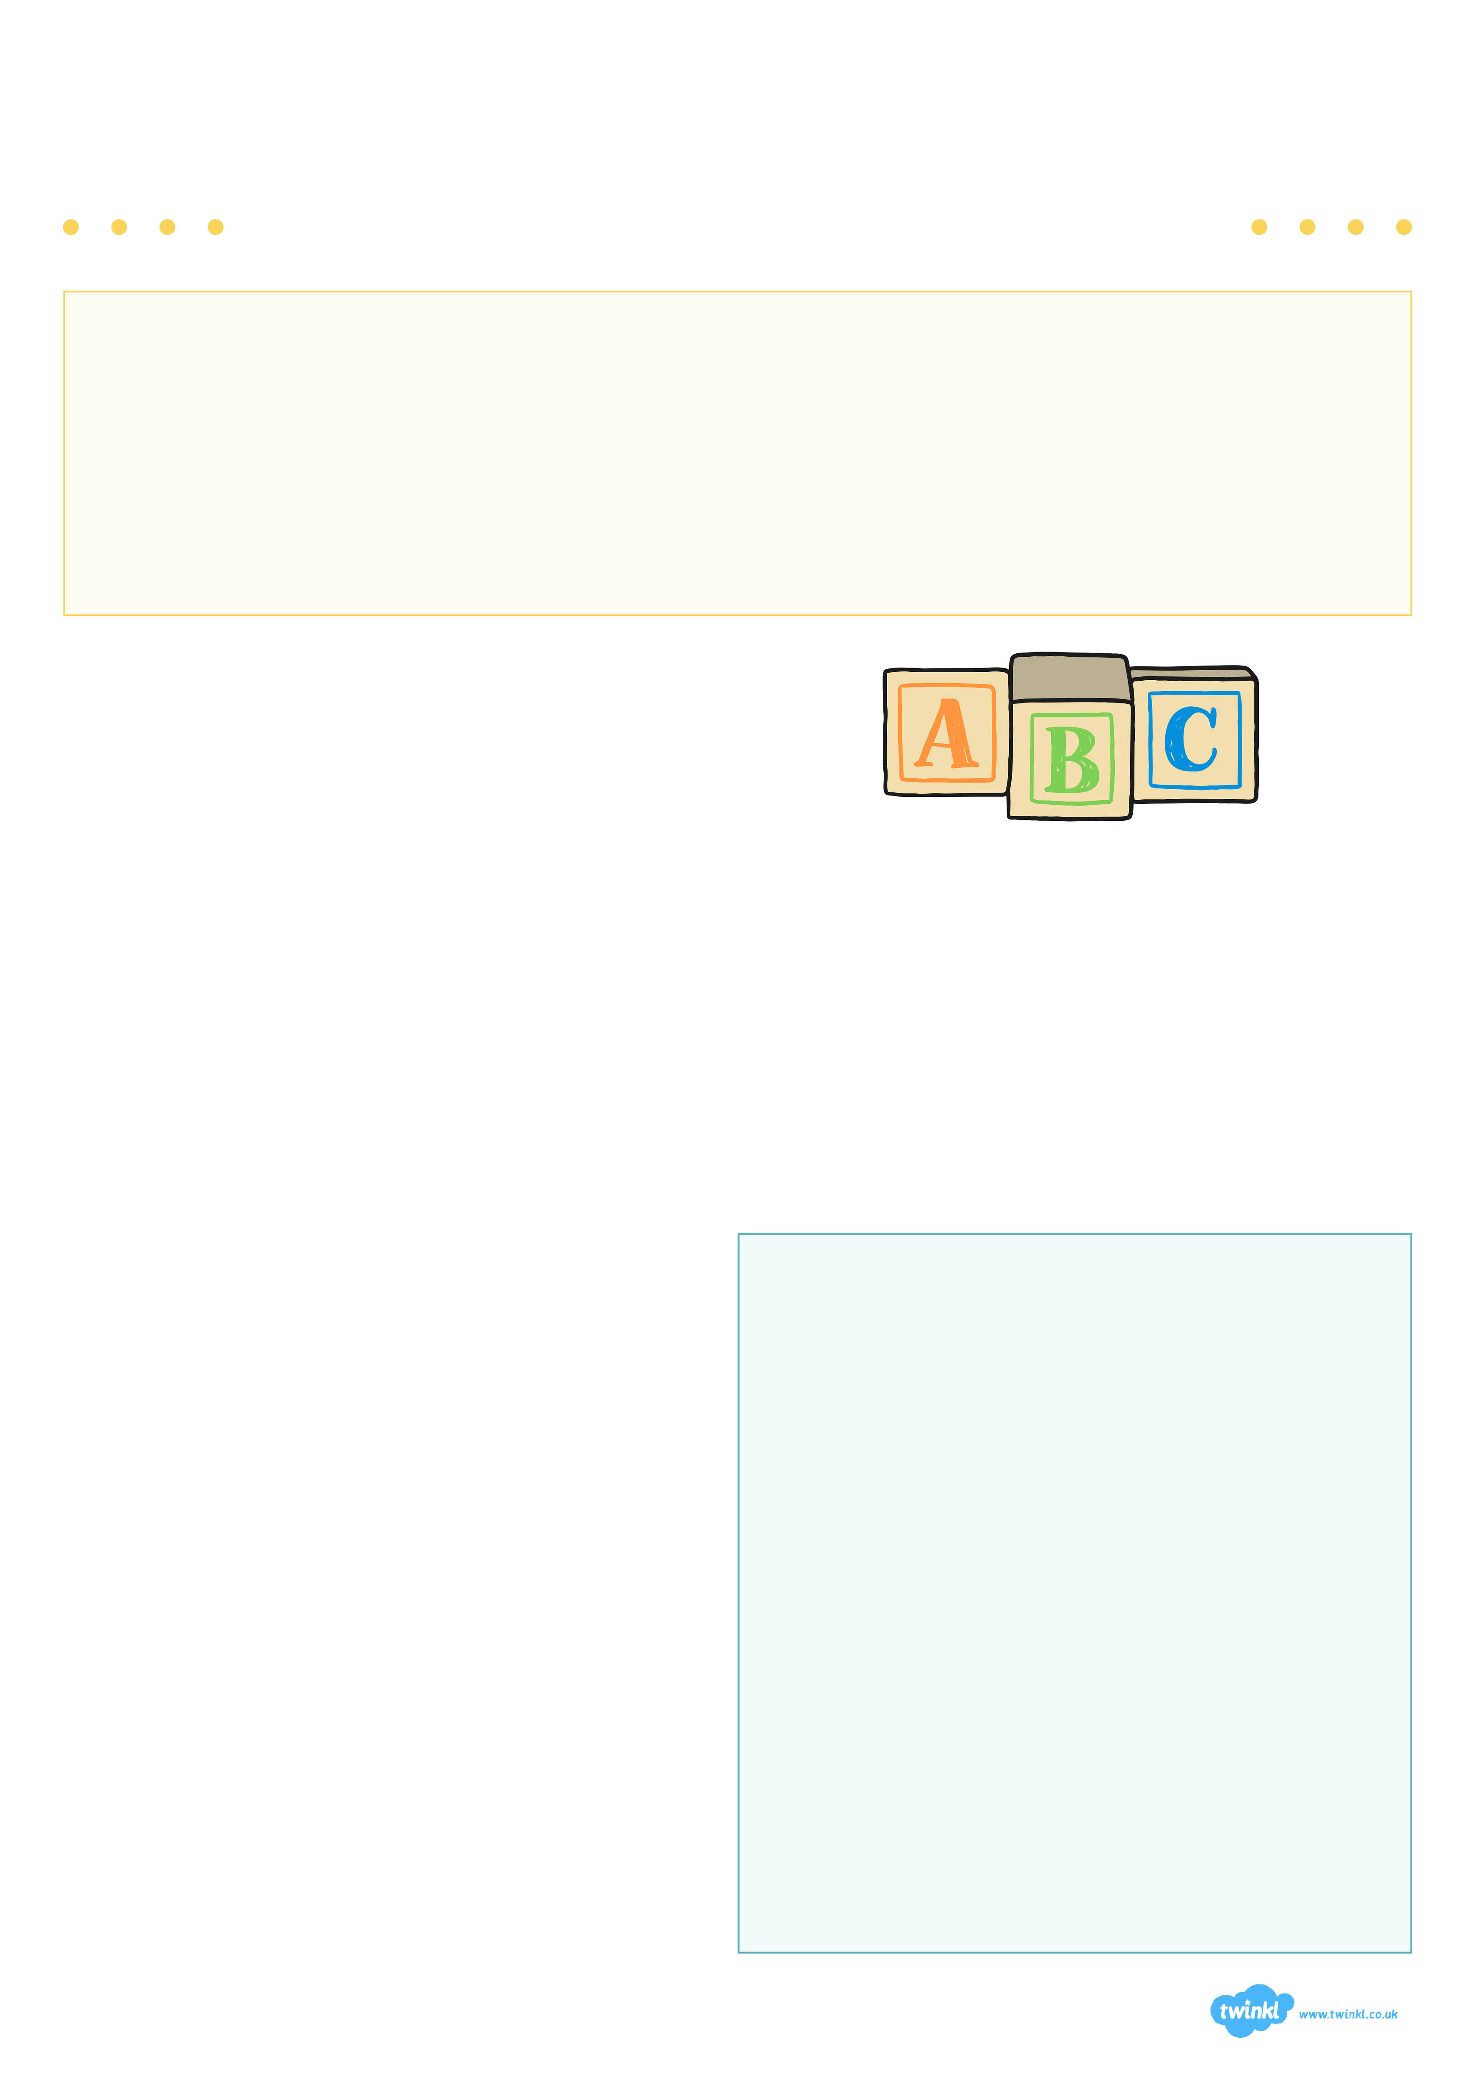
A Guide for Parents...
Year One
Phonics Screening Check

What is Phonics?
Children begin to learn phonics (sounds) in Early Years both Nursery and Reception. Once children begin learning sounds, these sounds are used to read and spell words. Children can then see the purpose of learning sounds.
For this reason, the first initial sounds that are taught are ‘s’, ‘a’, ‘t’, ‘p’, ‘i’, ‘n’. These can immediately be blended for reading to make simple CVC words (consonant, vowel, consonant) e.g. sat, pin. Children then develop segmenting for writing skills; breaking the word into sounds to spell it out.
What is the Phonics Screening Check?
Children in Year 1 throughout the country will all be taking part in a phonics screening check during the same week in June. Children in Year 2 will also take the check if they did not achieve the required result when in Year 1 or they have not taken the test before.
Head teachers should decide whether it is appropriate for each of their pupils to take the phonics screening check. The phonics screening check is designed to confirm whether individual children have learnt sufficient phonic decoding and blending skills to an appropriate standard.
What Happens During the Test?
The test contains 40 words. Each child will sit one to one and read each word aloud to a teacher. The test will take approximately 10 minutes per child, although all children are different and will complete the check at their own pace. The list of words the children read is a combination of 20 real words and 20 pseudo words (nonsense words).
Pseudo Words (Nonsense words)
The pseudo words will be shown to your child with a picture of an alien. This provides the children with a context for the pseudo word which is independent from any existing vocabulary they may have. Pseudo words are included because they will be new to all pupils; they do not favour children with a good vocabulary knowledge or visual memory of words.
Reporting to Parents
By the end of the summer term all schools must report their child’s results to parents. They will also confirm if the child has met the standard threshold. Children who do not achieve the expected level will retake the test when they are in Year 2.

How Are The Results Used?
Results from the check will be used by schools to analyse their own performance and for Ofsted to use in inspections.

“Read as much as possible to and with your child.”
How Can I Help My Child At Home?
- Play lots of sound and listening games with your child.
- Read as much as possible to and with your child.
- Encourage and praise – get them to have a ‘good guess’.
- If your child is struggling to decode a word, help them by encouraging them to say each sound in the word from left to right.
- Blend the sounds by pointing to each letter, e.g. /c/ in cat, or the letter group, e.g. /ng in sing. Next move your finger under the whole word as you say it.
- Discuss the meaning of words if your child does not know what they have read.

