RARE SOLAR ECLIPSE!
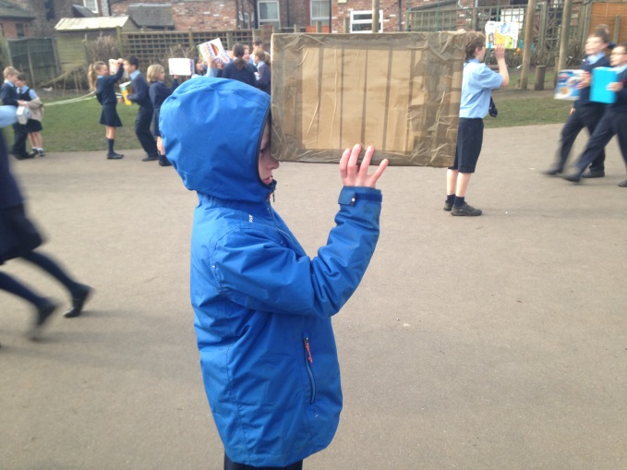
On Friday 20th March we witnessed this rare event. It was really exciting watching from the school playground.

If you don’t know what a solar eclipse is then here are some facts:
- A solar eclipse is when the moon passes between the sun and the Earth.
- The last solar eclipse was in 1999.
- Most people only see one solar eclipse in their lifetime.
- The next one to occur in the UK will be in 2026.

