**100 Books To Read In Key Stage 1**

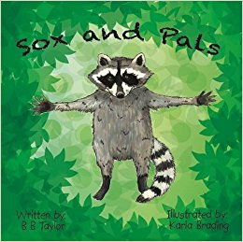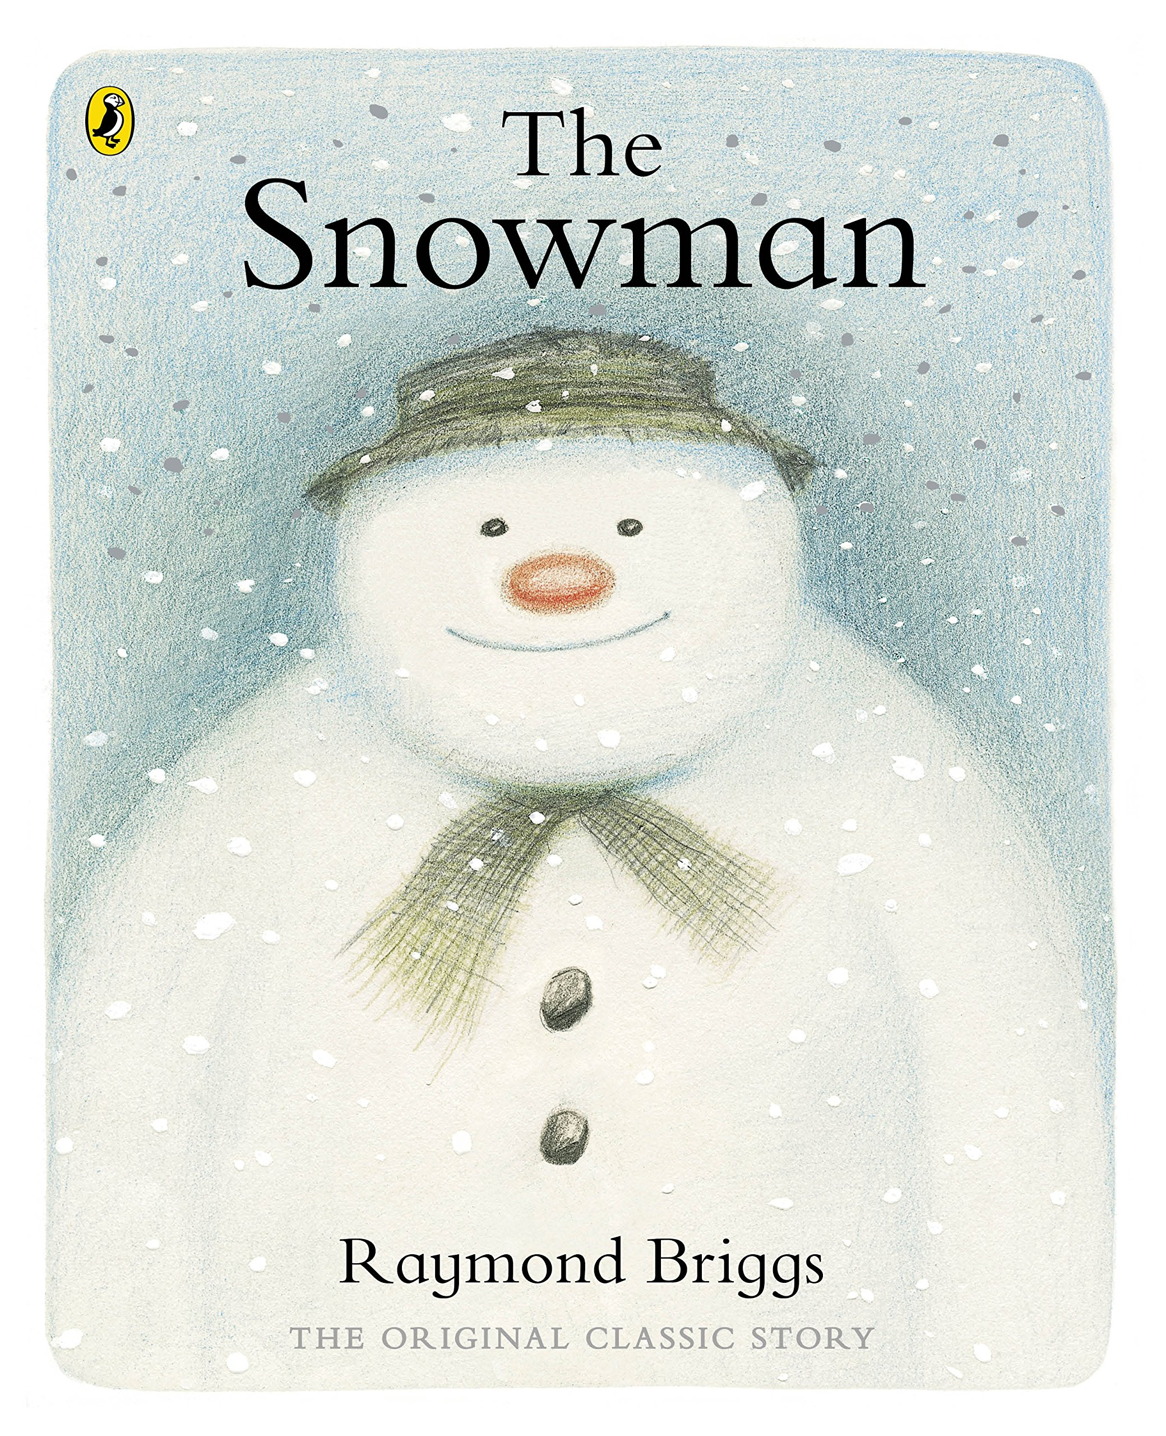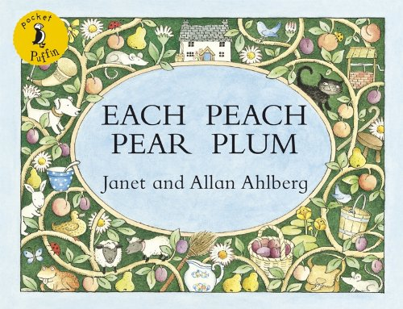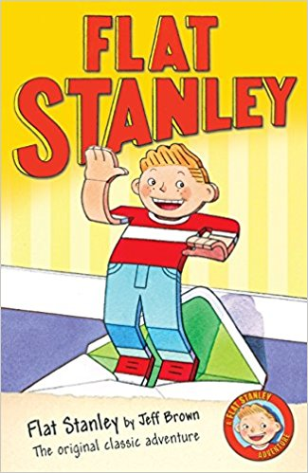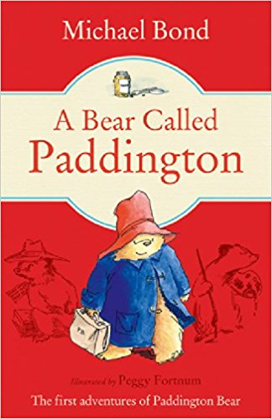

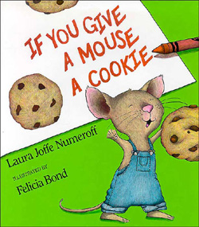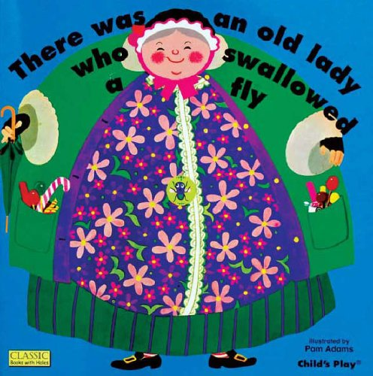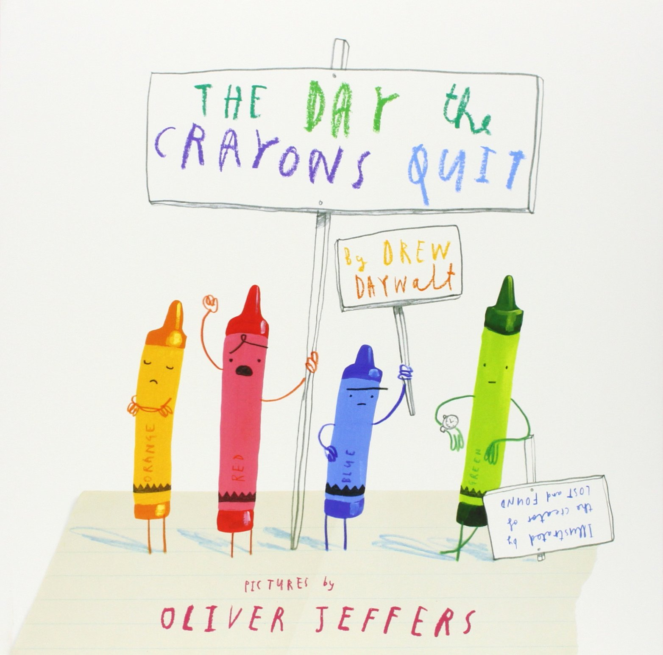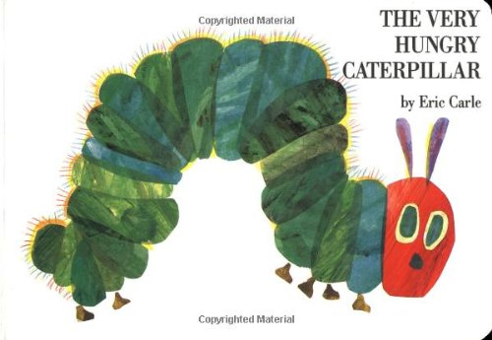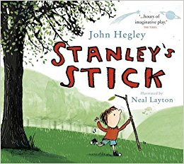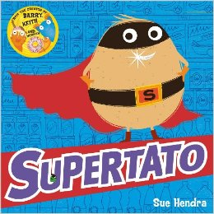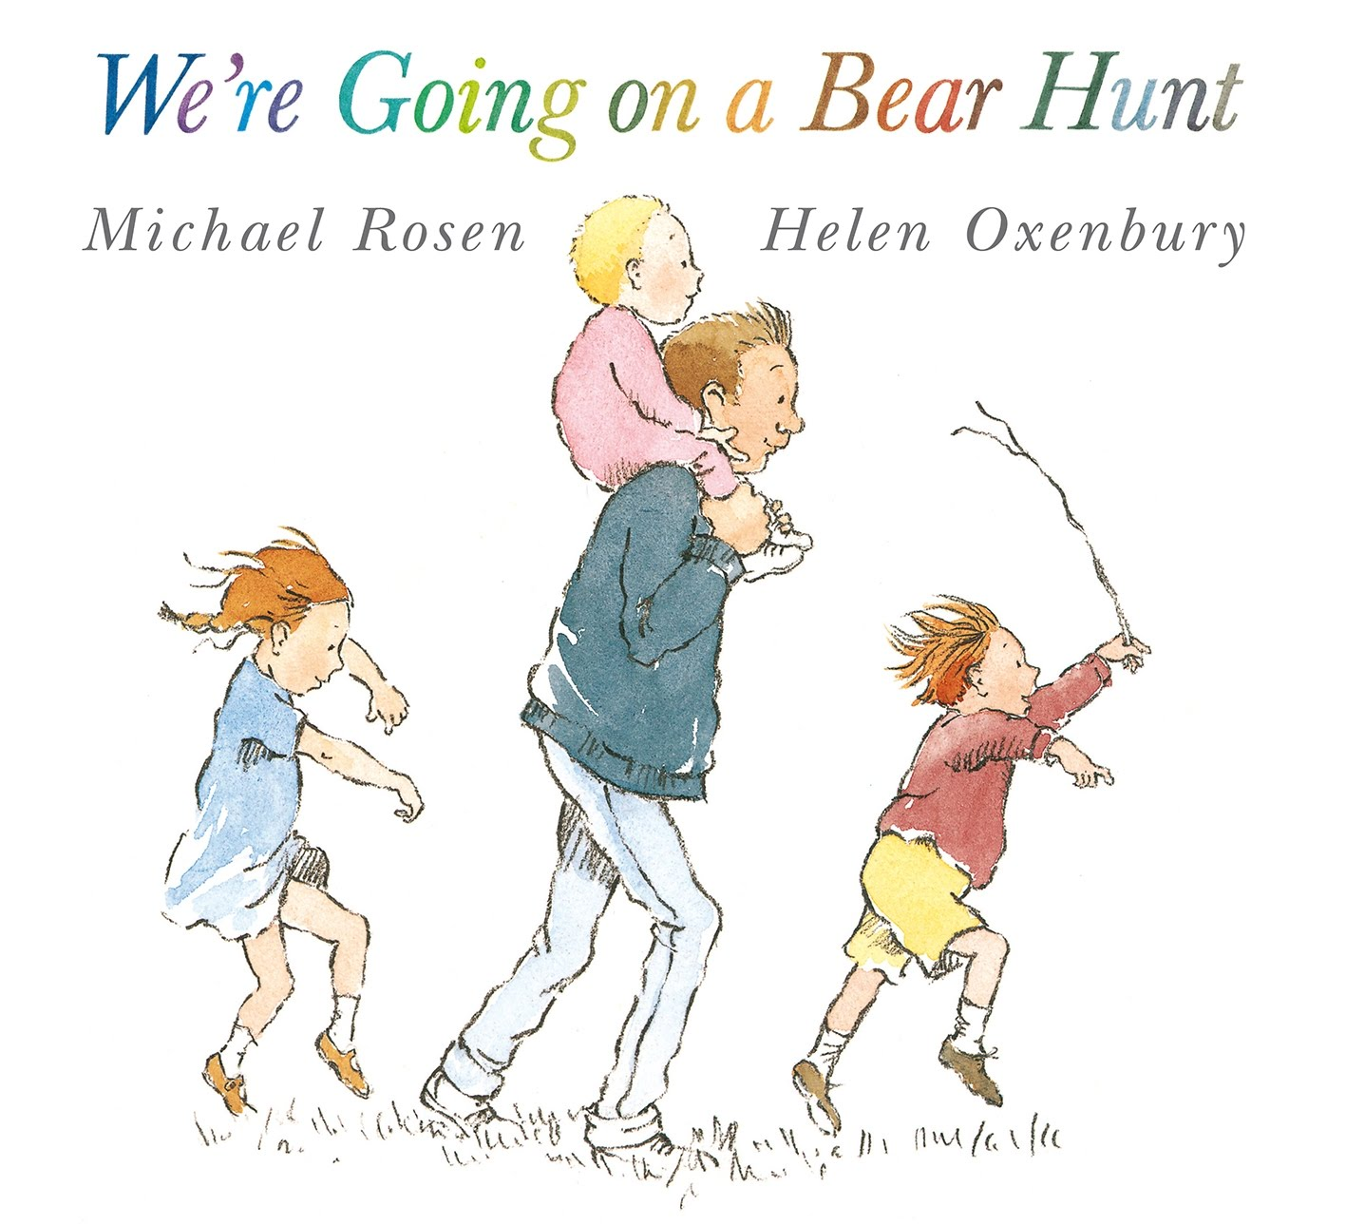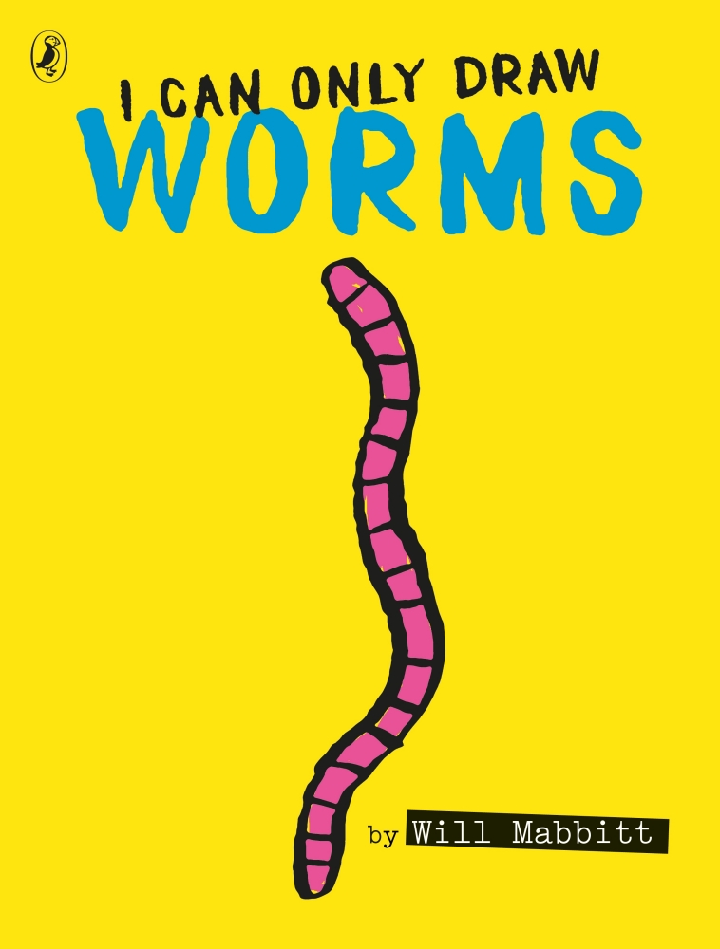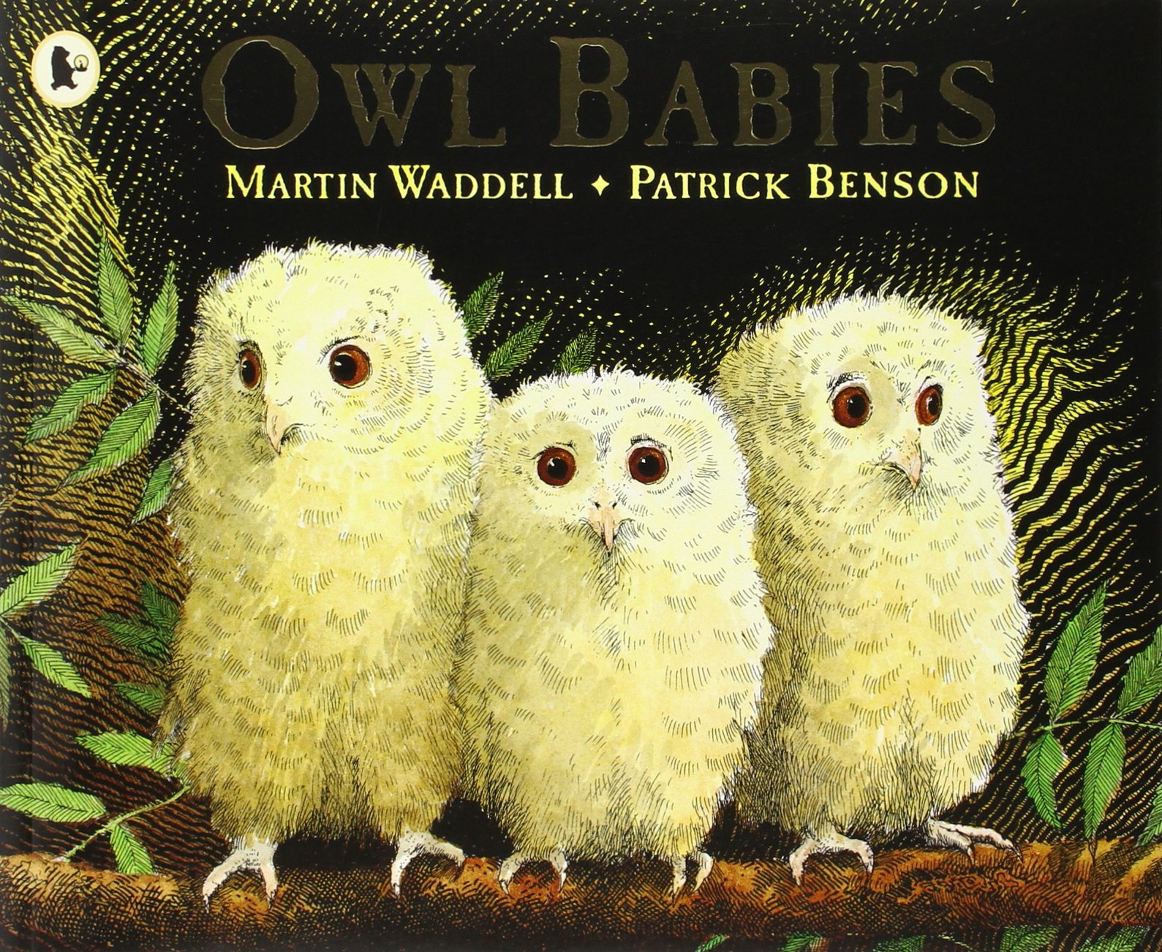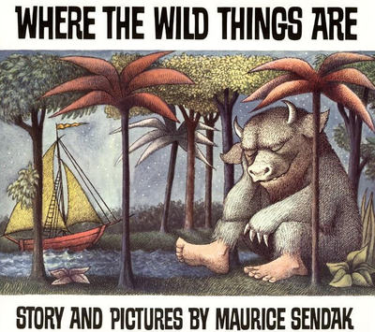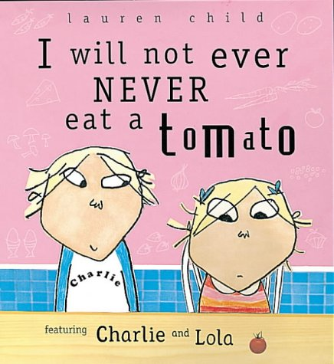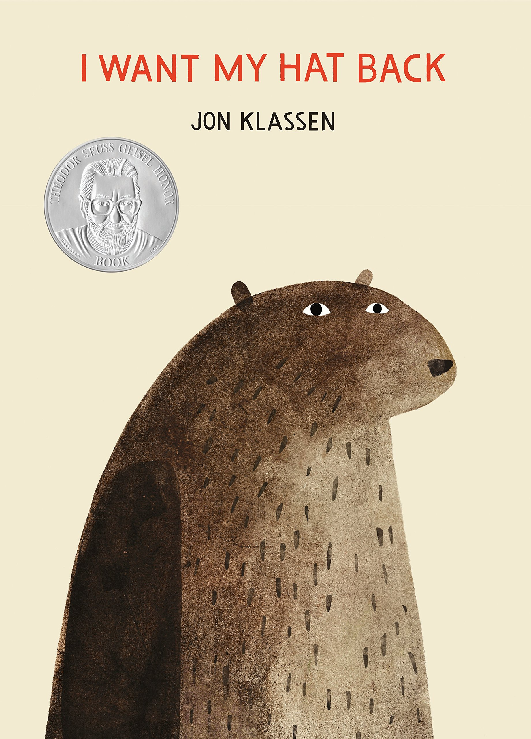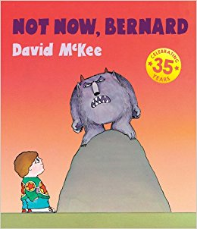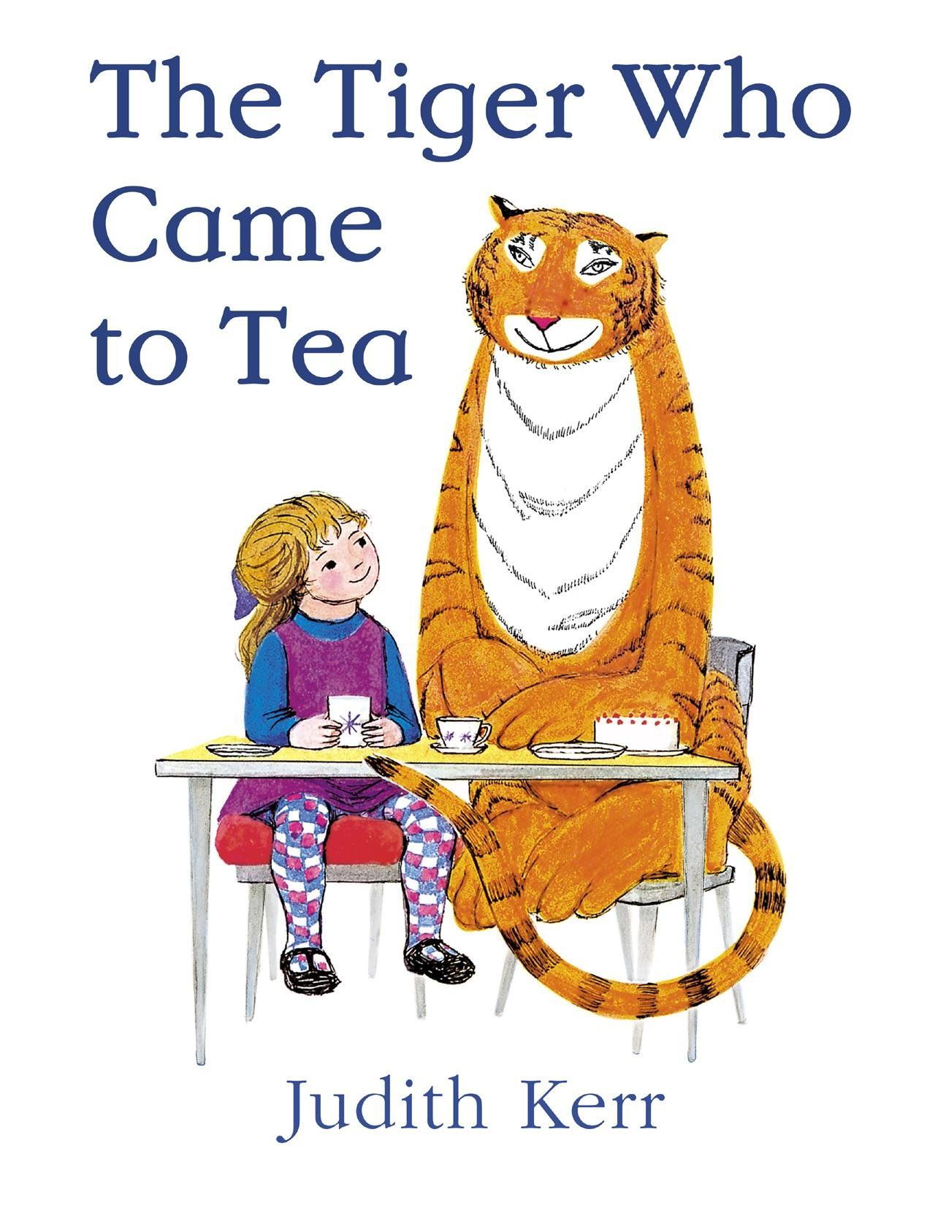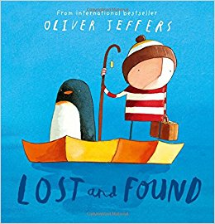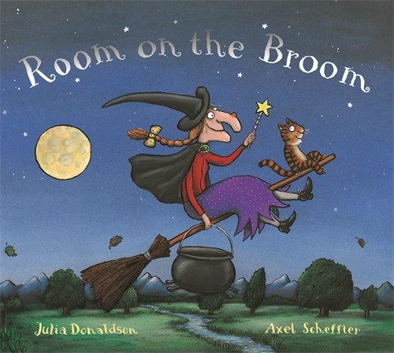

Where The Wild Things Are

Maurice Sendak

The Tiger Who Came To Tea

Judith Kerr

Sox and Pals

B B Taylor

If You Give A Mouse A Cookie

Laura Joffe Numeroff

There Was An Old Lady Who Swallowed A Fly

Pam Adams

The Day The Crayons Quit

Drew Daywalt

The Very Hungry Caterpillar

Eric Carle

Stanley’s Stick

John Hegley

Horrid Henry

Francesca Simon

We’re Going On A Bear Hunt

Michael Rosen

Each Peach Pear Plum

Janet and Allan Ahlberg

I Can Only Draw Worms

Will Mabbit

Owl Babies

Martin Waddell

I Will Never Not Eat A Tomato

Lauren Child

I Want My Hat Back

Jon Klassen

Not Now Bernard

David McKee

Lost and Found

Oliver Jeffers

Room On The Broom

Julia Donaldson and Axel Sheffler

The Snowman

Raymond Briggs

Flat Stanley

Jeff Brown

A Bear Called Paddington

Michael Bond